**Outputs, Inputs and Variables Worksheet – Year 8 Computer Studies**

**INPUT Displays a message and waits for a user input!**

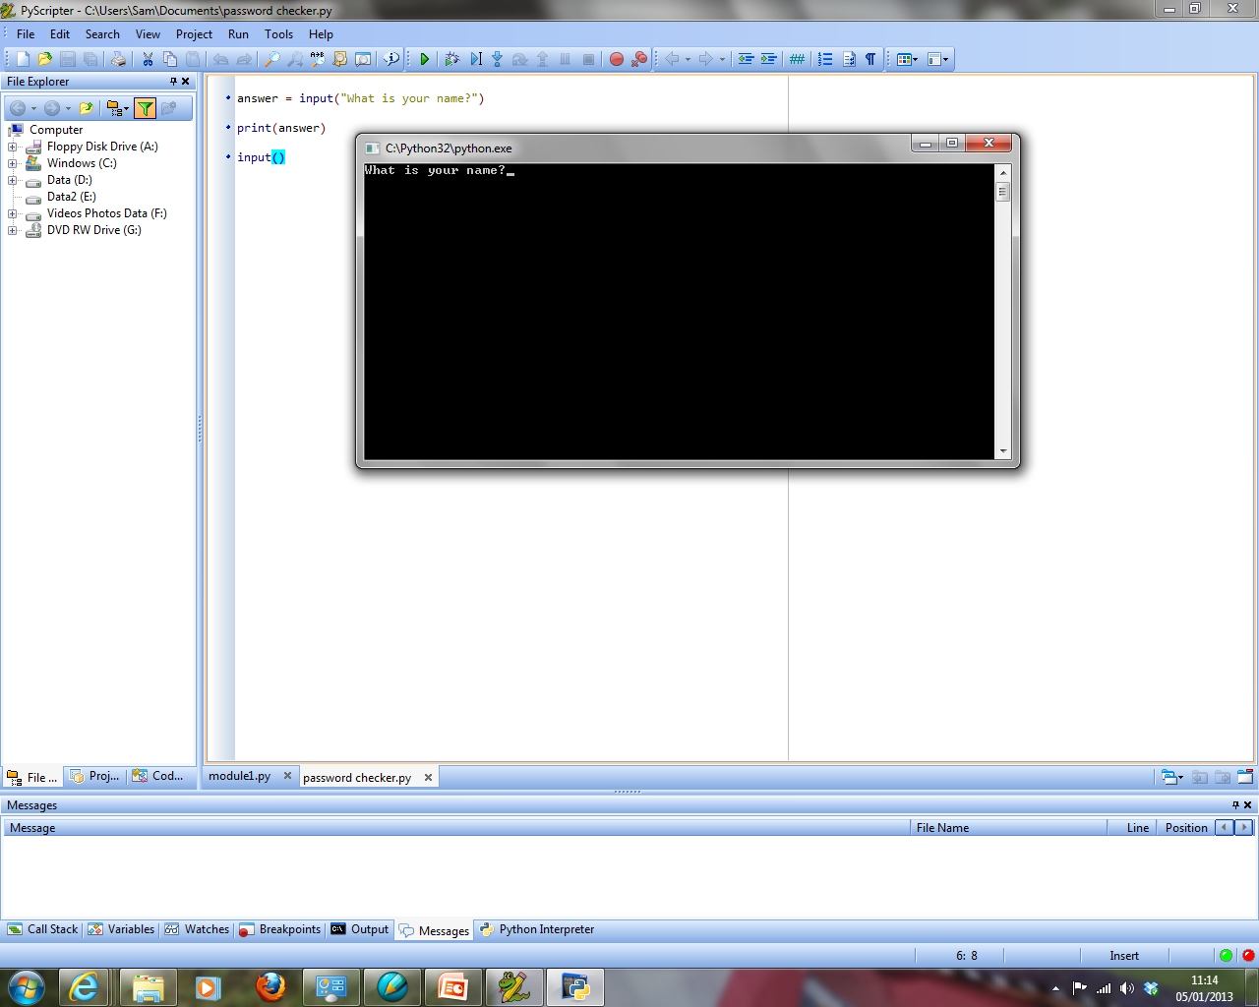**Things to remember:**

**PRINT just displays a message!**

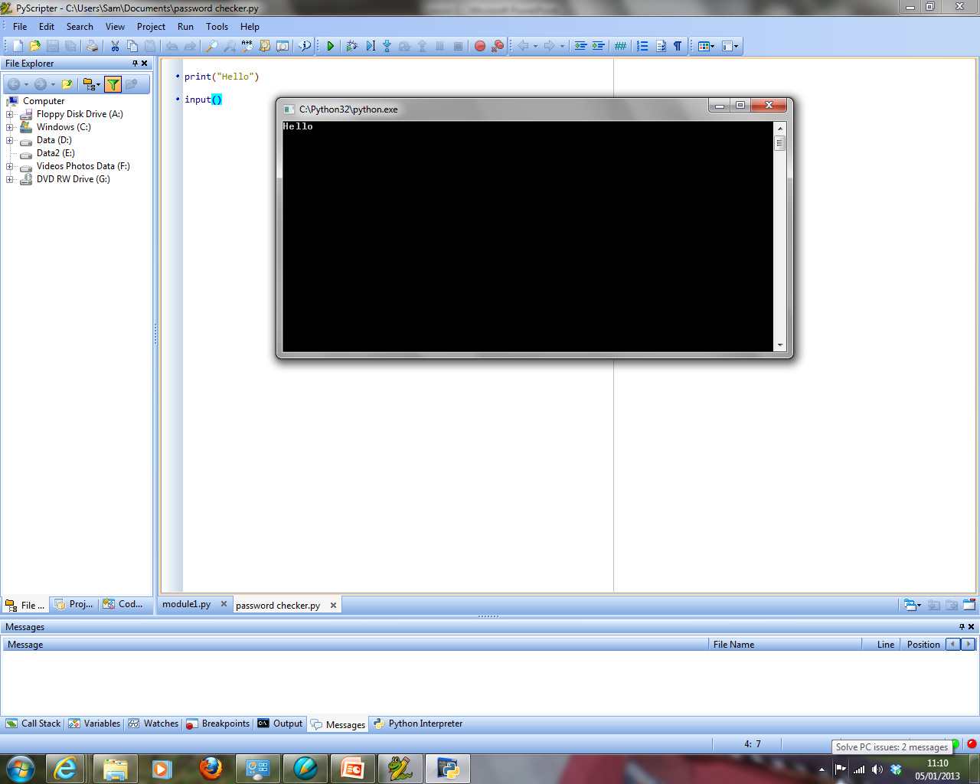



**So, it needs to equal a variable if we want to store what the user types in…**

See below for examples of the print statement and input statements written in Python:

**EXAMPLE 1 – Displaying / Printing to the Screen**



The print statement will display whatever is written in its brackets.

**Important**: If we want text (a datatype called a string) to display, it must be placed inside quotation marks.

**EXAMPLE 2 – Getting a User Input, Storing it and then Printing it to the Screen**

The input statement will display whatever is written in its brackets and then also wait for a user input. Notice here we are printing the contents of the variable (answer) and instead of a message – notice the lack of quotes!!

**Important**: If we want to store what the user types into the computer it needs to be stored. We do this by assigning a variable to the input statement (e.g.: **answer =** )



**Programming Activities**

The **examples** (shown above) will help with these tasks:

1. Write a program that will allow the user to input their name and age and then output the name and age that have been entered on the screen.
2. Write a program that will allow the user to input their name and then output the name joined with a greeting in the format: “Hello Joe”.
3. Write a program, similar to the one shown in the lesson, which does the following:
   1. Asks for your current level in all of your subjects
   2. Stores the inputs in different, suitably named variables
   3. Displays your current levels in an organised, well presented report on the screen
4. Write a program, similar to the one just shown, which does the following:
   1. Asks three questions
   2. Stores the inputs in different, suitably named variables
   3. Displays the answers in an organised, well presented report on the screen.